**How to start Using Git and Git hub**

**Step 1:**

**Install Git :-**

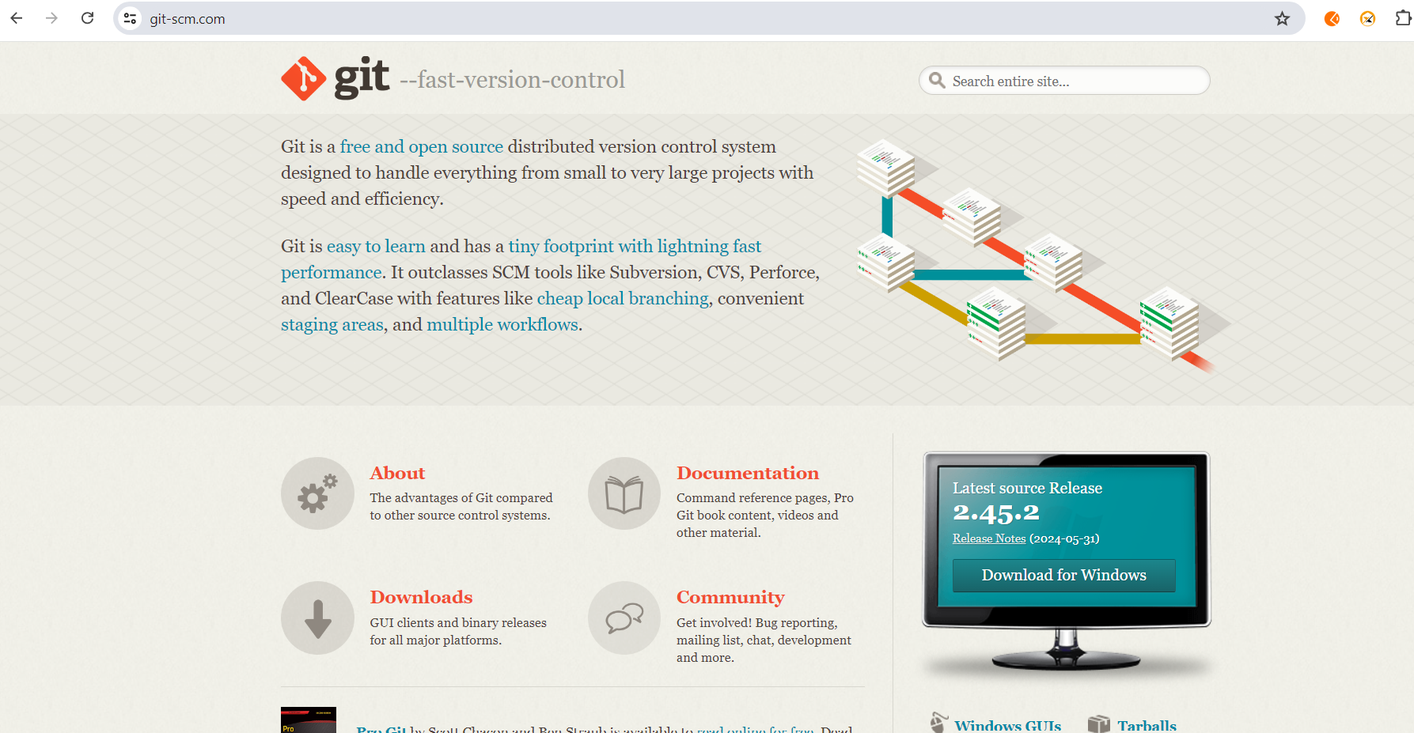

**Check git is successfully installed on not**

git --version or git version

set

**Step 2:**

Create a Github Account



**Step 3:**

**Connect your Github account to your Git account**

git config --global user.name “Soumya”

git config --global user.email “Soumya@gmail.com”

**Note : Make sure enter your Github username and user email**

**To confirm that you have set your git email and user name correctly**

git config --global user.name

git config --global user.email

**Step 4:**

Create and edit your code file locally (on local computer)

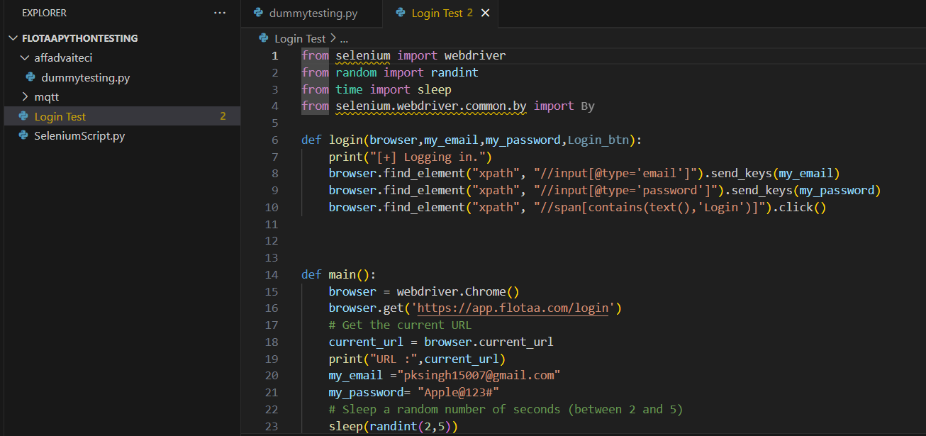

**Step 5:**

Create a repository on Github

**Click the + sign at the top right corner to create a new repository.**

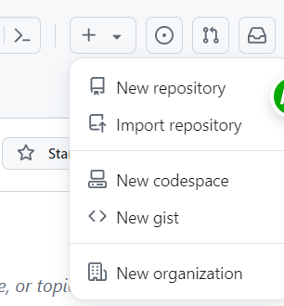

You will be prompted to this page:

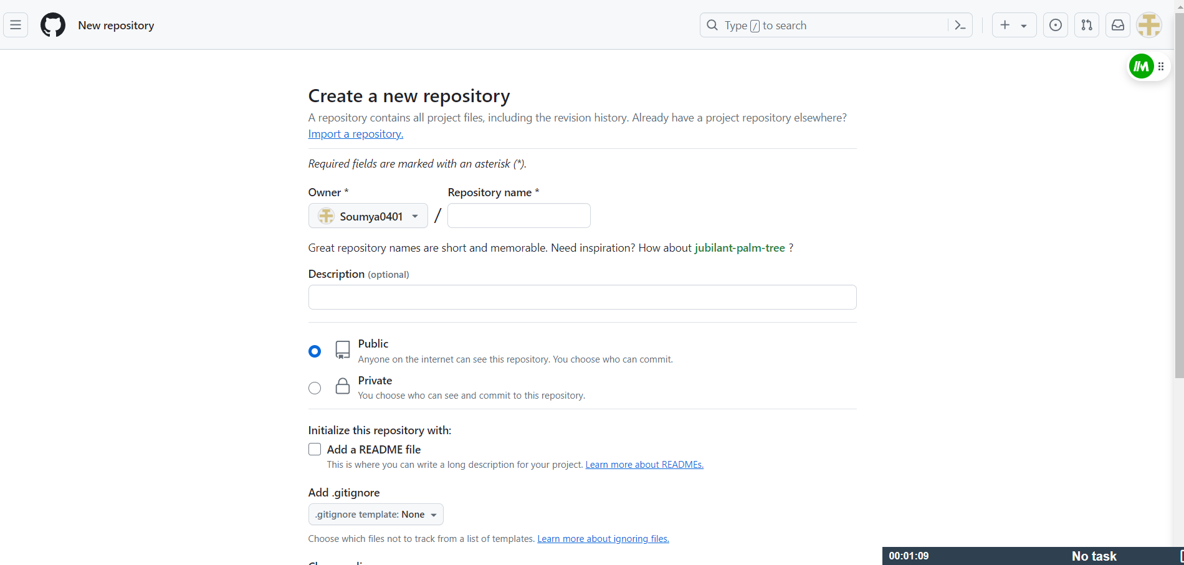

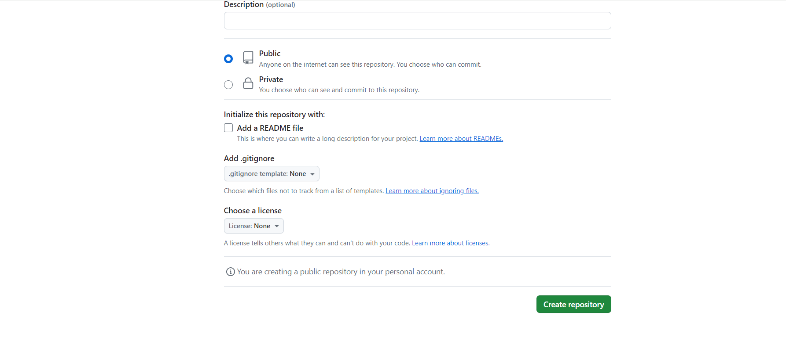

Name your repository and give it a description (this is optional).

Click the **"Create repository"** button to create the repository. You will be prompted to this page:

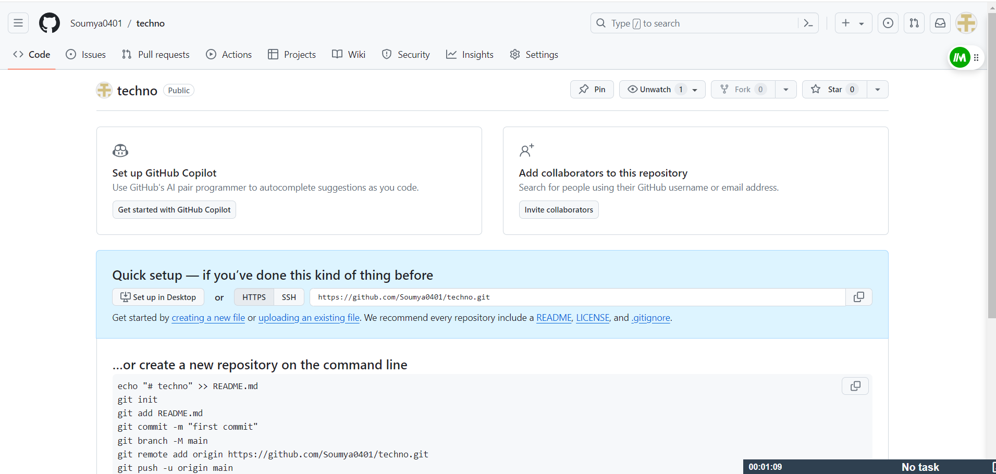

**Step 6:**

Push your local code to Github

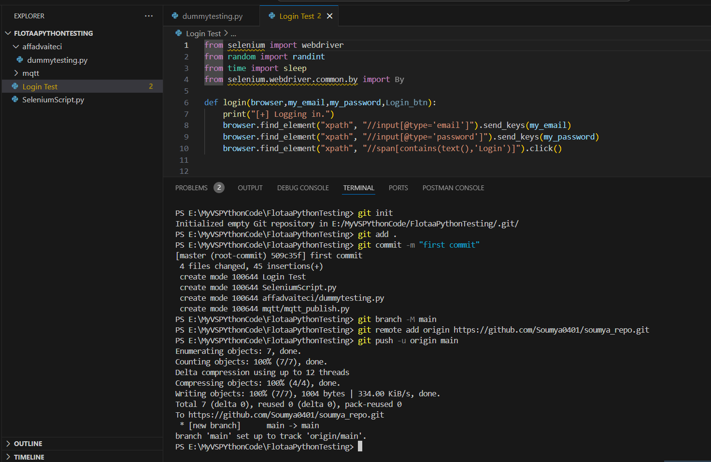

**git init** lets you initialize Git in your folder.

**git add .** lets you add all files in the present folder.

**git commit** stores the added files. Use -m for message followed by the actual message.

**git branch** creates a new branch which is a new version of the repository as it appears when added, and -M to move the name to main.

**git remote add origin** finally connects the local folder to the repository on GitHub. It is followed by the repository's link.

**git push -u origin main** pushes the code to GitHub. The -u flag creates a tracking reference for the branch, and origin main puts the code in the main branch.

**Command to be used for github**

git init

git add .

git commit -m "first commit"

git branch -M main

git remote add origin https://github.com/Soumya0401/techno.git

git push -u origin main

git remote add origin https://github.com/Soumya0401/techno.git

git branch -M main

git push -u origin main